Day 2 assignment

Print 5 \* in one line

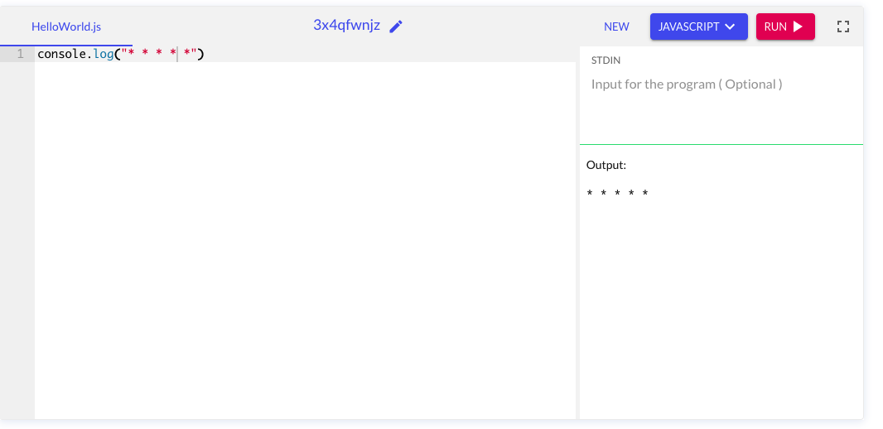

Caption